**UJIAN TENGAH SEMESTER**

**PEMOGRAMAN KOMPUTER 2**



**Disusun Oleh :**

Nama : Azam Putra Imanto

NIM : 18090011

Kelas : 4D

Prodi : DIV Teknik Informatika

Pengampu : M. Nishom, M.Kom.

**TEKNIK INFORMATIKA**

**POLITEKNIK HARAPAN BERSAMA TEGAL**

**2020**

Manual book Arsip Dokumentasi

Langkah pertama kita harus membuat database terlebih dahulu, caranya seperti berikut :

* 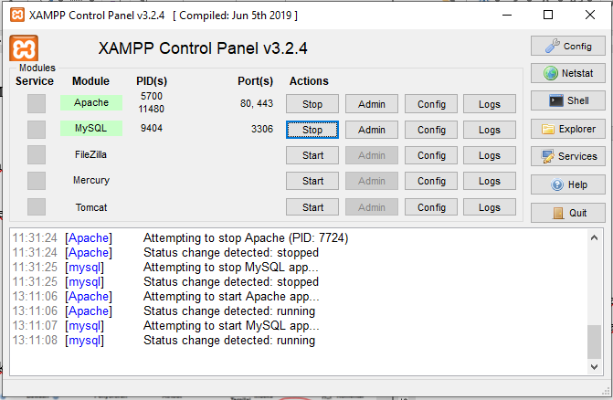Buka aplikasi Xampp dan aktifkan Apache dan MySQL
* Lalu kita buat database dengan nama dukumen dan membuat 2 table dengan nama (admin, data)

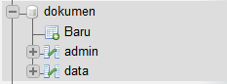

* Ditable admin kita buat isi table seperti :

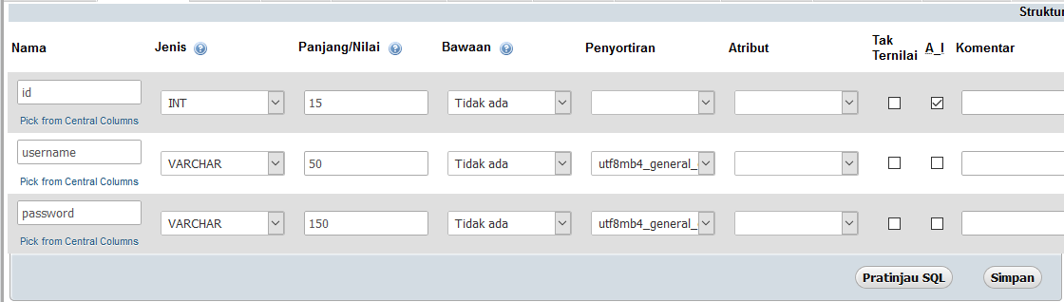

* Ditable data kita buat isi table seperti :

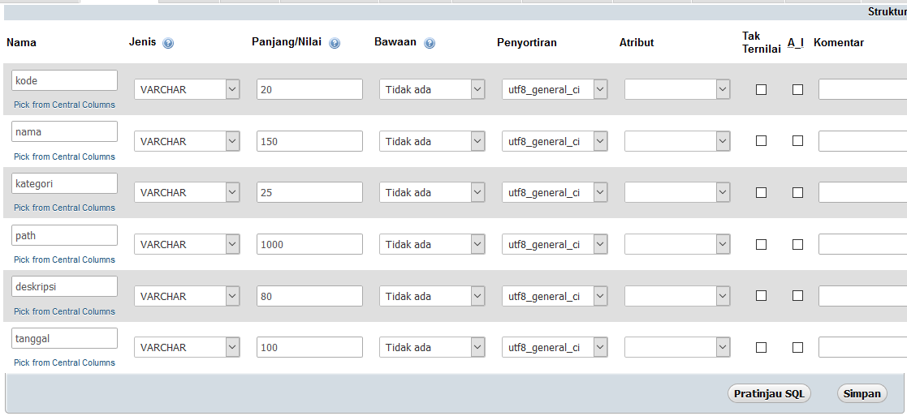

Membuat Project

* Buka Aplikasi Neatbean atau text editor yang anda punya, kali ini saya memakai text editor neatbean.

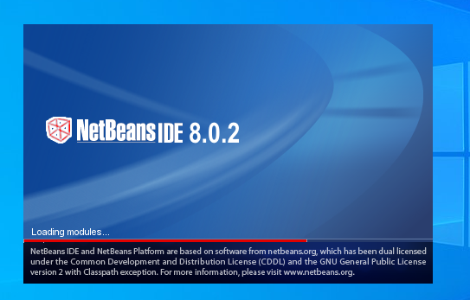

* Lalu buat Project dengan nama “UTS_PK2_Azam Putra Imanto_18090011_4D” atau nama file terserah kalian.
* Dan selanjutnya kita buat package dengan nama “Dokumen” atau nama package terserah kalian
* Selanjutnya kita buat class dengan nama koneksi untuk mengoneksikan project kita kedatabase

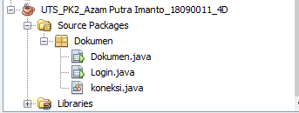

* Isi class koneksi.java adalah sebagai berikut

package Dokumen;

import java.sql.Connection;

/* Azam Putra Imanto(18090011)4D */

import java.sql.DriverManager;

import java.sql.SQLException;

public class koneksi {

private static Connection MySQLConfig;

public static Connection configDB() throws SQLException{

try {

String url = "jdbc:mysql://localhost:3306/dokumen";

String user = "root";

String pass = "";

DriverManager.registerDriver(new com.mysql.jdbc.Driver());

MySQLConfig = DriverManager.getConnection(url , user , pass);

} catch (Exception e) {

System.out.println("Koneksi Ke Database Gagal"+e.getMessage());

}

return MySQLConfig;

}

}

* Selanjutnya kita membuat Jframe Dukomen dan Login tampilanya seperti berikut.
* Tampilan Login

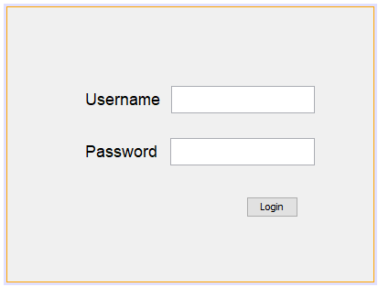

* Isi dari Jframe login adalah seperti berikut

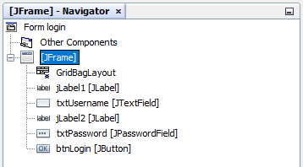

* Kodingan Jframe login adalah seperti berikut :

package Dokumen;

import java.awt.Frame;

import java.security.MessageDigest;

import java.security.NoSuchAlgorithmException;

/* Azam Putra Imanto(18090011)4D */

import java.sql.Connection;

import java.sql.ResultSet;

import java.sql.Statement;

import javax.swing.JOptionPane;

public class Login extends javax.swing.JFrame {

public Login() {

initComponents();

}

private void loginActionPerformed(java.awt.event.ActionEvent evt) {

doLogin();

}

public static void main(String args[]) {

java.awt.EventQueue.invokeLater(new Runnable() {

public void run() {

Login login = new Login();

login.setExtendedState(Frame.MAXIMIZED_BOTH);

new Login().setVisible(true);

}

});

}

private javax.swing.JLabel jLabel1;

private javax.swing.JLabel jLabel2;

private javax.swing.JButton login;

private javax.swing.JPasswordField password;

private javax.swing.JTextField username;

public void doLogin() {

login.setEnabled(false);

String user = username.getText();

char[] pass = password.getPassword();

if (user.isEmpty()) {

JOptionPane.showMessageDialog(this, "Username harus diisi");

username.requestFocus();

} else if (pass.length == 0) {

JOptionPane.showMessageDialog(this, "Password harus diisi");

password.requestFocus();

} else {

String password = new String(pass);

String md5_pass = md5(password);

try {

Connection c = koneksi.configDB();

Statement st = c.createStatement();

String q = " SELECT * FROM admin "

+ "WHERE username = '" + user + "' "

+ "AND password = '" + md5_pass + "'";

ResultSet rs = st.executeQuery(q);

int n = 0;

while (rs.next()) {

String u = rs.getString("username");

String p = rs.getString("password");

n++;

}

if (n == 0) {

JOptionPane.showMessageDialog(this, "Username/password salah!");

username.requestFocus();

login.setEnabled(true);

}

else {

Dokumen kar = new Dokumen();

this.setVisible(false);

kar.setExtendedState(Frame.MAXIMIZED_BOTH);

kar.setVisible(true);

}

} catch (Exception e) {

System.out.println(e.getMessage());

}

}

}

public static String md5(String data) {

String hashed = "";

try {

MessageDigest md5 = MessageDigest.getInstance("MD5");

md5.update(data.getBytes());

byte[] byteData = md5.digest();

StringBuilder sb = new StringBuilder();

for (int i = 0; i < byteData.length; i++) {

sb.append(Integer.toString((byteData[i] & 0xff)

+ 0x100, 16).substring(1));

}

hashed = sb.toString();

} catch (NoSuchAlgorithmException e) {

}

return hashed;

}

}

* Tampilan Dokumen

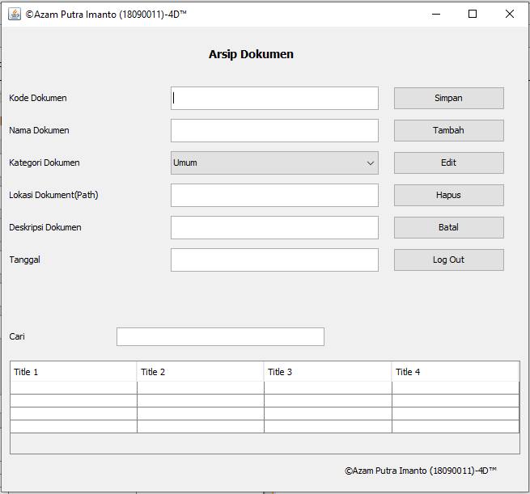

* Isi dari Jframe login adalah seperti berikut :

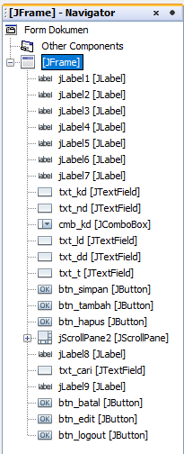

* Kodingan Jframe Dokumen adalah seperti berikut :

package Dokumen;

import java.awt.HeadlessException;

import java.sql.Connection;

/* Azam Putra Imanto(18090011)4D */

import java.sql.SQLException;

import javax.swing.JOptionPane;

import javax.swing.table.DefaultTableModel;

public class Dokumen extends javax.swing.JFrame {

private void kosongkan_from() {

txt_kd.setEditable(true);

txt_kd.setText(null);

txt_nd.setText(null);

cmb_kd.setSelectedItem(this);

txt_ld.setText(null);

txt_dd.setText(null);

txt_t.setText(null);

}

private void tampilkan_data() {

DefaultTableModel model = new DefaultTableModel();

model.addColumn("No.");

model.addColumn("Kode Dokumen");

model.addColumn("Nama Dokumen");

model.addColumn("Kategori Dokumen");

model.addColumn("Lokasi Dokumen");

model.addColumn("Deskripsi Dokumen");

model.addColumn("Tanggal");

String cari= txt_cari.getText();

try {

int no = 1;

String sql = "SELECT *FROM data WHERE nama LIKE '%"+cari+"%' ";

java.sql.Connection conn = (Connection)koneksi.configDB();

java.sql.Statement stm = conn.createStatement();

java.sql.ResultSet res = stm.executeQuery(sql);

while (res.next()) {

model.addRow(new Object[]{no++,res.getString(1),

res.getString(2),res.getString(3),res.getString(4),res.getString(5),res.getString(6)});

}

tbl_data.setModel(model);

} catch (Exception e) {

System.out.println("Error : "+e.getMessage());

}

}

public Dokumen() {

initComponents();

tampilkan_data();

kosongkan_from();

}

// KODINGAN HAPUS DATA

private void btn_batalActionPerformed(java.awt.event.ActionEvent evt) {

kosongkan_from();

}

// KODINGAN LOGOUT DATA

private void btn_logoutActionPerformed(java.awt.event.ActionEvent evt) {

System.exit(0);

}

// KODINGAN SIMPAN DATA

private void btn_simpanActionPerformed(java.awt.event.ActionEvent evt) {

try {

String sql = "INSERT INTO data VALUES ('"+ txt_kd.getText() +"', '"+ txt_nd.getText() +"',

'"+ cmb_kd.getSelectedItem() +"', '"+ txt_ld.getText() +"', '"+ txt_dd.getText() +"', '"+ txt_t.getText() +"')";

java.sql.Connection conn = (Connection)koneksi.configDB();

java.sql.PreparedStatement pstm = conn.prepareStatement(sql);

pstm.execute();

JOptionPane.showMessageDialog(null, "Proses simpan Data berhasil");

tampilkan_data();

kosongkan_from();

} catch (HeadlessException | SQLException e) {

JOptionPane.showMessageDialog(this, e.getMessage());

}

}

// KODINGAN TAMBAH DATA

private void btn_tambahActionPerformed(java.awt.event.ActionEvent evt) {

try {

String sql = "INSERT INTO data VALUES ('"+ txt_kd.getText() +"', '"+ txt_nd.getText() +"', '"+ cmb_kd.getSelectedItem() +"', '"+ txt_ld.getText() +"', '"+ txt_dd.getText() +"', '"+ txt_t.getText() +"')";

java.sql.Connection conn = (Connection)koneksi.configDB();

java.sql.PreparedStatement pstm = conn.prepareStatement(sql);

pstm.execute();

JOptionPane.showMessageDialog(null, "Proses simpan Data berhasil");

tampilkan_data();

kosongkan_from();

} catch (HeadlessException | SQLException e) {

JOptionPane.showMessageDialog(this, e.getMessage());

}

txt_kd.setFocusable(true);

}

//KODINGAN PENAMPILAN TABLE

private void tbl_dataMouseClicked(java.awt.event.MouseEvent evt) {

int baris = tbl_data.rowAtPoint(evt.getPoint());

String kode = tbl_data.getValueAt(baris, 1).toString();

txt_kd.setText(kode);

String nama = tbl_data.getValueAt(baris, 2).toString();

txt_nd.setText(nama);

String kategori = tbl_data.getValueAt(baris, 3).toString();

cmb_kd.setSelectedItem(kategori);

String lokasi = tbl_data.getValueAt(baris, 4).toString();

txt_ld.setText(lokasi);

String deskripsi = tbl_data.getValueAt(baris, 5).toString();

txt_dd.setText(deskripsi);

String tanggal = tbl_data.getValueAt(baris, 6).toString();

txt_t.setText(tanggal);

}

//KODINGAN EDIT DATA

private void btn_editActionPerformed(java.awt.event.ActionEvent evt) {

try {

String sql = "UPDATE data SET kode = '"+ txt_kd.getText() +"', nama = '"+ txt_nd.getText() +"', kategori = '"+ cmb_kd.getSelectedItem() +"', lokasi = '"+ txt_ld.getText() +"', deskripsi = '"+ txt_dd.getText() +"', tanggal = '"+ txt_t.getText() +"' WHERE kode = '"+ txt_kd.getText() +"'";

java.sql.Connection conn = (Connection)koneksi.configDB();

java.sql.PreparedStatement pstm = conn.prepareStatement(sql);

pstm.execute();

JOptionPane.showMessageDialog(null, "Edit Data Berhasil");

} catch (HeadlessException | SQLException e) {

JOptionPane.showMessageDialog(this, e.getMessage());

}

tampilkan_data();

kosongkan_from();

}

//KODINGAN HAPUS DATA

private void btn_hapusActionPerformed(java.awt.event.ActionEvent evt) {

try {

String sql = "DELETE FROM data WHERE kode = '"+txt_kd.getText()+"'";

java.sql.Connection conn = (Connection)koneksi.configDB();

java.sql.PreparedStatement pstm = conn.prepareStatement(sql);

pstm.execute();

JOptionPane.showMessageDialog(null, "Hapus Data Berhasil");

} catch (HeadlessException | SQLException e) {

JOptionPane.showMessageDialog(this, e.getMessage());

}

tampilkan_data();

kosongkan_from();

}

//KODINGAN CARI DATA

private void txt_cariKeyPressed(java.awt.event.KeyEvent evt) {

tampilkan_data();

}

public static void main(String args[]) {

java.awt.EventQueue.invokeLater(new Runnable() {

public void run() {

new Dokumen().setVisible(true);

}

});

}

private javax.swing.JButton btn_batal;

private javax.swing.JButton btn_edit;

private javax.swing.JButton btn_hapus;

private javax.swing.JButton btn_logout;

private javax.swing.JButton btn_simpan;

private javax.swing.JButton btn_tambah;

private javax.swing.JComboBox cmb_kd;

private javax.swing.JLabel jLabel1;

private javax.swing.JLabel jLabel2;

private javax.swing.JLabel jLabel3;

private javax.swing.JLabel jLabel4;

private javax.swing.JLabel jLabel5;

private javax.swing.JLabel jLabel6;

private javax.swing.JLabel jLabel7;

private javax.swing.JLabel jLabel8;

private javax.swing.JLabel jLabel9;

private javax.swing.JScrollPane jScrollPane2;

private javax.swing.JTable tbl_data;

private javax.swing.JTextField txt_cari;

private javax.swing.JTextField txt_dd;

private javax.swing.JTextField txt_kd;

private javax.swing.JTextField txt_ld;

private javax.swing.JTextField txt_nd;

private javax.swing.JTextField txt_t;

}

Tampilan Halaman Login

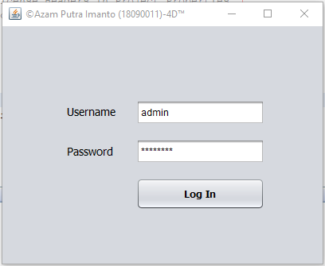

Tampilan Halaman Document

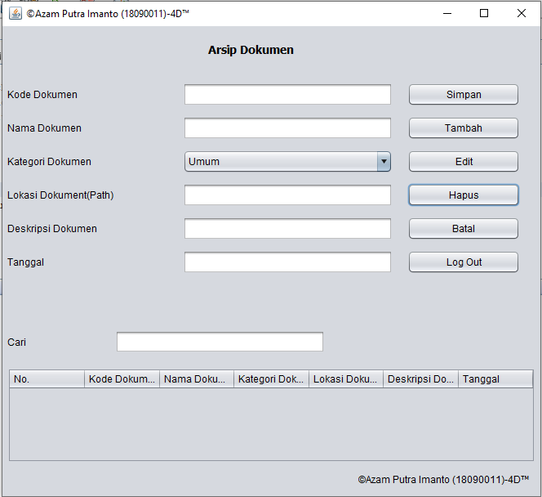

Tampilan Simpan Data

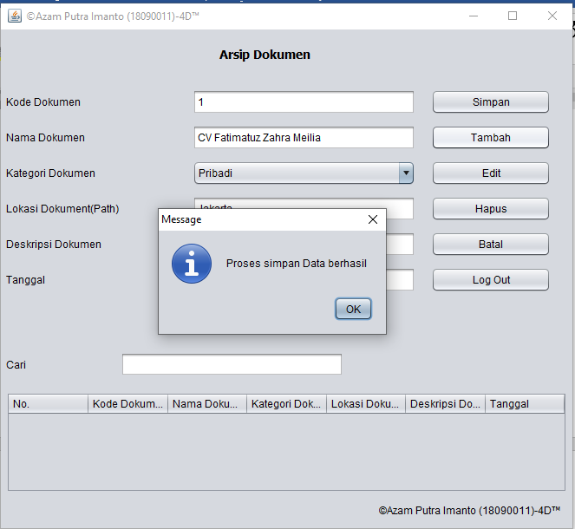

Tampilan Hapus Data

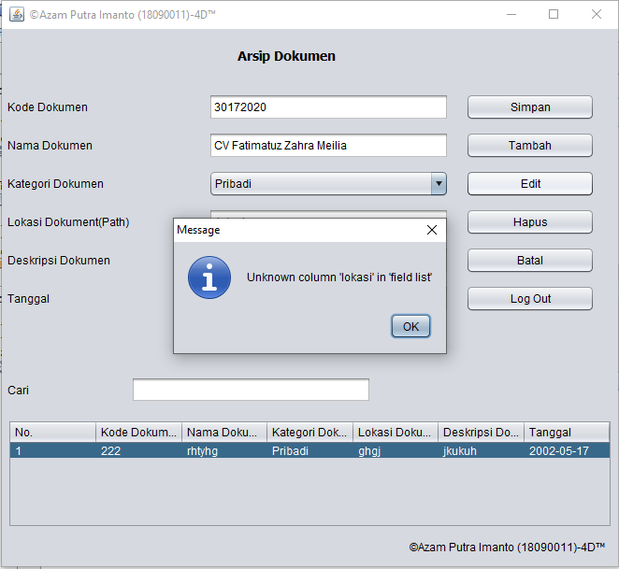

Tampilan Database Document



Tampilan Database Admin

